
RETURNING ALL OF OUR HERO
THEIR FAMILIES AND BRINGING
THEM HOME WITH HONOR
VFW AUXILIARY NATIONAL PRESIDENT
DONNA K. MILLS
& VFW NATIONAL COMMANDER-IN-CHIEF
CORY L. GEISLER
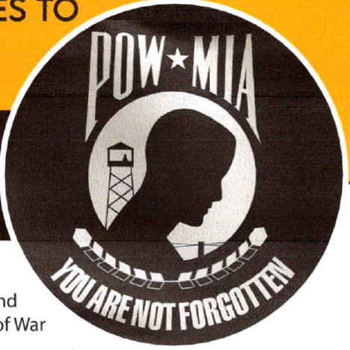
The DPAA (Defense POW/MIA Accounting Agency) is a
Department of Defense agency that works to account for ar
repatriate U.S. service members who are or were Prisoners c
(POW) or Missing in Action (MIA) from past conflicts. Its mission is to
provide families and the nation with the most complete record of these missing personnel.
The DPAA uses a combination of historical research, recovery operations and forensic science
including analyzing DNA to identify remains and bring them home.

To support this project, select the"Make a
Gift" ta b and then "National President's 2026-
2027 Special Project" in MALTA. Or mail a
check to National Headquarters earmarked
"National President's/Commander-in-Chief's
2026-2027 Special Project." Members may also
mail gifts earmarked for the special project to
the VFW Foundation.
Members can report this under the Veterans
& Family Support Program. Also reportable
under Veterans & Family Support and integral
to DPAA's efforts is what is called a Family
Resource Sample (FRS). DNA from surviving
family members is key to identifying missing
loved ones. It is technology that did not exist
when these troops were lost.

Helping this organization means helping families find peace. Your contributions will
help fund the DPAA's efforts. To learn more about DPAA, visit www.dpaa.mil.
Send donations to: MI VFW Aux. Earmark Checks: Operations Bring them Home.
1117 Michigan St.
Midland, MI 48640

